‬‬‬‬‬‬‬‬‬‬‬‬‬‬‬‬‬‬‬‬‬‬‬‬‬‬‬‬‬‬‬‬‬‬‬‬‬‬‬‬‬‬‬‬‬‬‬‬‬‬‬‬‬‬‬‬‬‬‬‬‬‬‬‬‬‬‬‬‬‬‬‬‬‬‬‬‬‬‬‬‬‬‬‬‬‬‬‬‬‬‬‬‬‬‬‬‬‬‬‬‬‬‬‬‬‬‬‬‬‬‬‬‬‬‬‬‬‬‬‬‬‬‬‬‬‬‬‬‬‬‬‬‬‬‬‬‬‬‬‬‬‬‬‬‬‬‬‬‬‬‬‬‬‬‬‬‬‬‬‬‬‬‬‬‬‬‬‬‬‬‬‬‬‬‬‬‬‬‬‬‬‬‬‬‬‬‬‬‬‬‬‬‬‬‬‬‬‬‬‬‬‬‬‬‬‬‬‬‬‬‬‬‬‬‬‬‬‬‬‬‬‬‬‬‬‬‬‬‬‬‬‬‬‬‬‬‬‬‬‬‬‬‬‬‬‬‬‬‬‬‬‬‬‬‬‬‬‬‬‬‬‬‬‬‬‬‬‬‬‬‬‬‬‬‬‬‬‬‬‬‬‬‬‬ ‬
04 April 2017
Mine Rehabilitation Conference
The 2017 Best Practice Ecological Rehabilitation of Mined Lands Conference was organised by the Tom Farrell Institute for the Environment (TFI).
The conference brought mine rehabilitation stakeholders together to share their current best practises, covering what they do well, what they can improve and what they would like the future to be.
The conference was a great success with a number of key regulatory representatives in attendance including Stephen Barry, Director Resources Policy, NSW Department of Planning and Environment and Matthew Newton, Assistant Director Environmental Regulation and Standards, Mineral Resources, NSW Department of Industry.
Karin Fogarty, Environmental Advisor at Wilpinjong represented Peabody and was invited to present Wilpinjong’s rehabilitation practices, current and proposed trials and projects including:
- Wilpinjong’s approach to integrated planning and implementation
- Operational trials including:
  - Soil testing and the use of different ameliorates
  - Green manure crops
  - Microbe investigations
  - Proposed rehabilitation prescribed burn
- Current investigation into Final Landform Drainage System Design.
Karin’s presentation was very well received and was voted by the scientific committee as the best presentation at the event. Karin was approached by various participants to discuss Wilpinjong’s approach with soil testing, green manure crops and microbes.
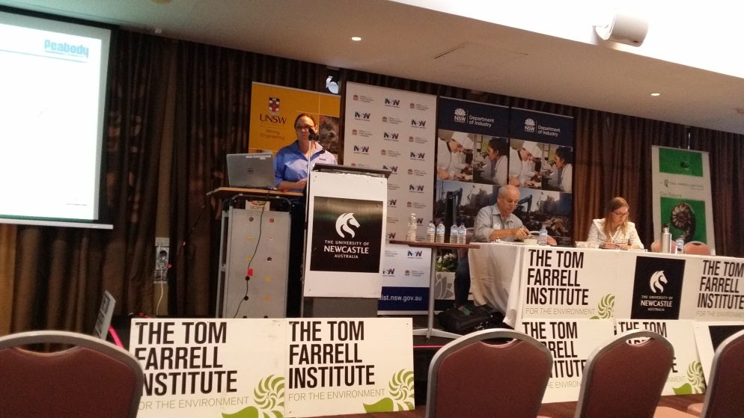
Matthew Newton of NSW Department of Industry also presented and shared images of Wilpinjong from his recent visit, providing commentary on how Wilpinjong integrates rehabilitation into the existing landform. He also discussed how Wilpinjong actively rehabs behinds operations.

