18 April 2017‬‬‬‬‬‬‬‬‬‬‬‬‬‬‬‬‬‬‬‬‬‬‬‬‬‬‬‬‬‬‬‬‬‬‬‬‬‬‬‬‬‬‬‬‬‬‬‬‬‬‬‬‬‬‬‬‬‬‬‬‬‬‬‬‬‬‬‬‬‬‬‬‬‬‬‬‬‬‬‬‬‬‬‬‬‬‬‬‬‬‬‬‬‬‬‬‬‬‬‬‬‬‬‬‬‬‬‬‬‬‬‬‬‬‬‬‬‬‬‬‬‬‬‬‬‬‬‬‬‬‬‬‬‬‬‬‬‬‬‬‬‬‬‬‬‬‬‬‬‬‬‬‬‬‬‬‬‬‬‬‬‬‬‬‬‬‬‬‬‬‬‬‬‬‬‬‬‬‬‬‬‬‬‬‬‬‬‬‬‬‬‬‬‬‬‬‬‬‬‬‬‬‬‬‬‬‬‬‬‬‬‬‬‬‬‬‬‬‬‬‬‬‬‬‬‬‬‬‬‬‬‬‬‬‬‬‬‬‬‬‬‬‬‬‬‬‬‬‬‬‬‬‬‬‬‬‬‬‬‬‬‬‬‬‬‬‬‬‬‬‬‬‬‬‬‬‬‬‬‬‬‬‬‬ ‬‬

Central Tablelands Australian Stock Horse Society – Branch Show
Central Tablelands Branch Australian Stock Horse (ASH) hosted their annual Show and Challenges on Saturday, 18 and Sunday, 19 March 2017 at Gulgong Showground.
Peabody was the major sponsor of the Open Challenge with an outright first place prize of $1000, with remaining monies divided among the other placegetters.
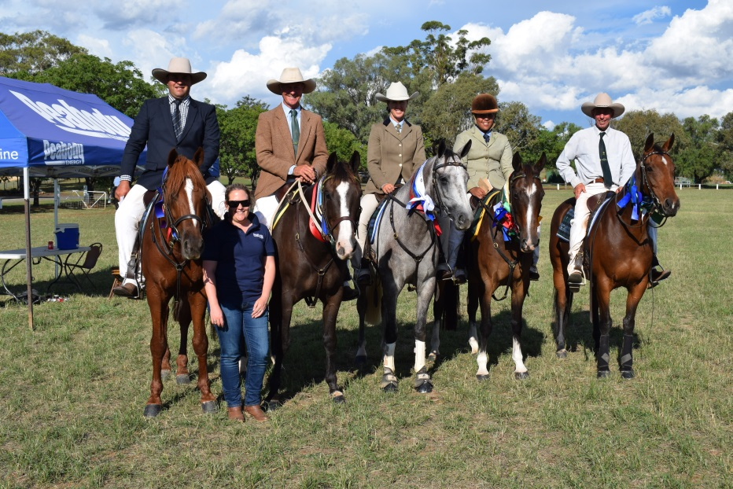
A Challenge Event is made up of different disciplines and is one of the most competed for events. Kellie Smith of Wilpinjong was invited to present the ribbons to the place getters and overall winner.
Overall winners of the Peabody Open Challenge pictured with Kellie Smith were (listed left to right in the above photo):
- 1st place - Clint Parker riding Waylon J Fort Destiny from Merriwa
- 2nd place - Bruce Withers riding Walleroo Dealer from Singleton
- 3rd place - Kim Frazer riding Chalay Kamakzie from Wollar
- 4th place - Mutesi Blake riding Oasis Bud Bundy from Penrith (youth rider)
- 5th place - Warren Poganoski riding Ivory Cricket from Gulgong
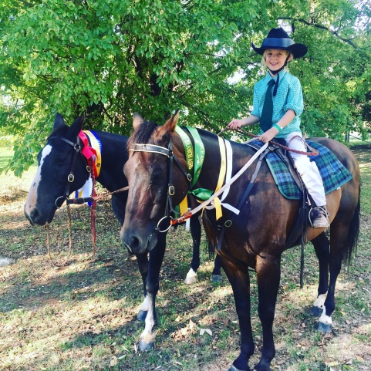

Pictured: Nine year old Ella Barnett (daughter of Chris Barnett at Wilpinjong) on her horse ‘Awesome’.

