20 February 2017

|  |
| --- |
|  |
|  |

**Mudgee’s 2017 Showgirl**

On Saturday, 11 February, Wilpinjong’s **Kellie Smith** and **Lisa Andrews** attended the Mudgee Showgirl competition at the Parklands Resort. Wilpinjong mine were Gold Sponsors of the event.

Each year the Mudgee Show Society nominates a girl aged between 18-24 years to become an ambassador for the community. This year Lucy Meers-Hundy and Lara McNair were nominated.

The girls are judged on personality, confidence, ambitions and goals, general knowledge, rural knowledge, personal presentation, and their community participation.

The winner of the competition was Lucy Meers-Hundy. Lucy completed year 12 at Mudgee High School in 2016 and is currently taking a gap year to work locally and travel. Next year Lucy will head to Bathhurst CSU to study nursing and hopes to work in rural NSW.

The Mudgee Showgirl represents the Mudgee Show Society and the entire community at the Zone 5 Finals. In the last six years Mudgee has had three girls go through to the State finals.

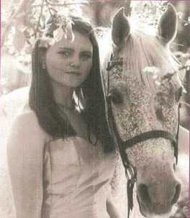****

2017 Mudgee Showgirl: Lucy Meers-Hundy Runner-up: Lara McNair