6 September 2017

Taking a Unique Approach to Rehabilitation

‬‬
Wilpinjong mine was recently recognised for its approach to rehabilitation when it received the runner up position at the NSW Mining HSEC Awards.
Their unique approach is not just about the process - it's about the people.
Blair Jackson, Wilpinjong General Manager, has been hugely supportive of the Operational Support Team (OST), made up of employees with agricultural backgrounds who work closely with the Environment team.
"The OST has been critical to the success of our rehab. They know the land and what grows best," Blair said.
The team can apply their knowledge to the rehab areas as the seasonal changes require it, and then contribute to other areas of the mine during the off season.
Karin Fogarty, Environmental Advisor, works with the OST and sees first-hand the range of benefits.
"These crops are helping with dust management, erosion and sediment control," Karin said.
Wilpinjong opened in 2006 and even though the mine is still young, approximately 300 hectares of land has already been rehabilitated.
We congratulate the Wilpinjong team on their hard work and great achievement!
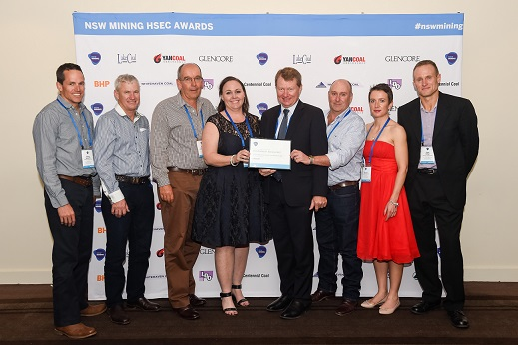
Wilpinjong's Environment and Operational Support Team members and General Manager, Blair Jackson (centre, holding the certificate).

