10 March 2017
Wilpinjong Inspires Next Generation of Miners
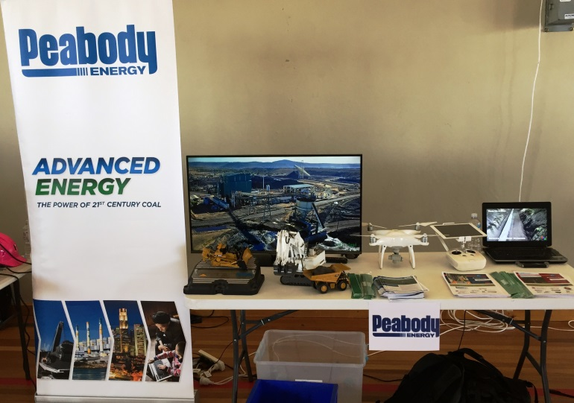
Wilpinjong employees hosted a stand at St Matthew's Careers Expo in Mudgee on Thursday, 9 March to encourage young minds to consider a career in the mining industry. The students chatted about rocks, drones and large equipment and even participated in a resources specific word find. The students were keen to learn about the industry and we may just see a few of them working on site in the coming years!
