13 February 2017

‬‬‬‬‬‬‬‬‬‬‬‬‬‬‬‬‬‬‬‬‬‬‬‬‬‬‬‬‬‬‬‬‬‬‬‬‬‬‬‬‬‬‬‬‬‬‬‬‬‬‬‬‬‬‬‬‬‬‬‬‬‬‬‬‬‬‬‬‬‬‬‬‬‬‬‬‬‬‬‬‬‬‬‬‬‬‬‬‬‬‬‬‬‬‬‬‬‬‬‬‬‬‬‬‬‬‬‬‬‬‬‬‬‬‬‬‬‬‬‬‬‬‬‬‬‬‬‬‬‬‬‬‬‬‬‬‬‬‬‬‬‬‬‬‬‬‬‬‬‬‬‬‬‬‬‬‬‬‬‬‬‬‬‬‬‬‬‬‬‬‬‬‬‬‬‬‬‬‬‬‬‬‬‬‬‬‬‬‬‬‬‬‬‬‬‬‬‬‬‬‬‬‬‬‬‬‬‬‬‬‬‬‬‬‬‬‬‬‬‬‬‬‬‬‬‬‬‬‬‬‬‬‬‬‬‬‬‬‬‬‬‬‬‬‬‬‬‬‬‬‬‬‬‬‬‬‬‬‬‬‬‬‬‬‬‬‬‬‬‬Wilpinjong Sponsors Waratahs v Brumbies

The NSW Waratahs had their first trial match at Mudgee’s Glen Willow Regional Sports Stadium in a blockbuster local rugby union derby against the ACT Brumbies on Saturday, 4 February.

Proudly sponsored by Peabody and Wilpinjong mine the trial match saw 6,357 turn up to watch the Waratah’s defeat the Brumbies 53-17.

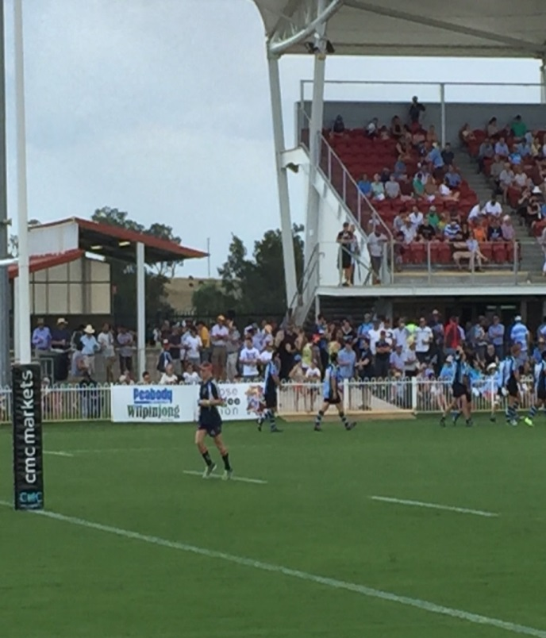
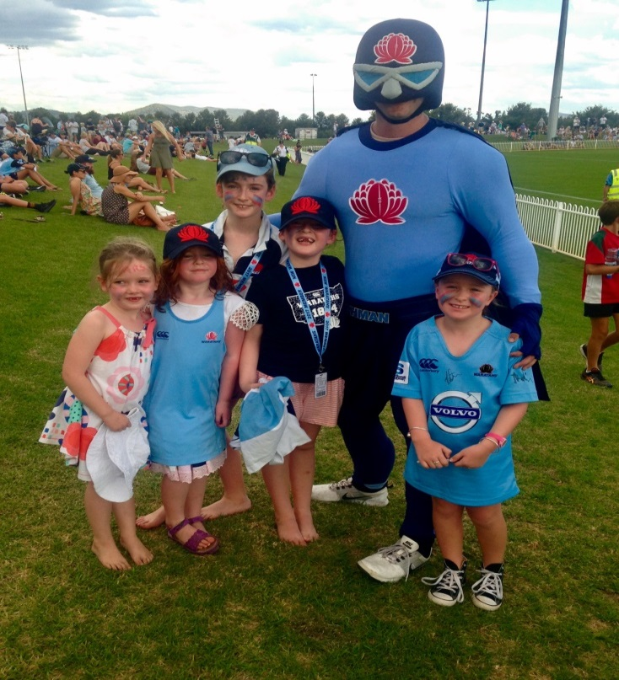

Wilpinjong employees got into the action at the rugby with Peabody’s Nicola Searle taking her daughter Audrey and friends to meet the Waratah’s mascot “Tah Man”

